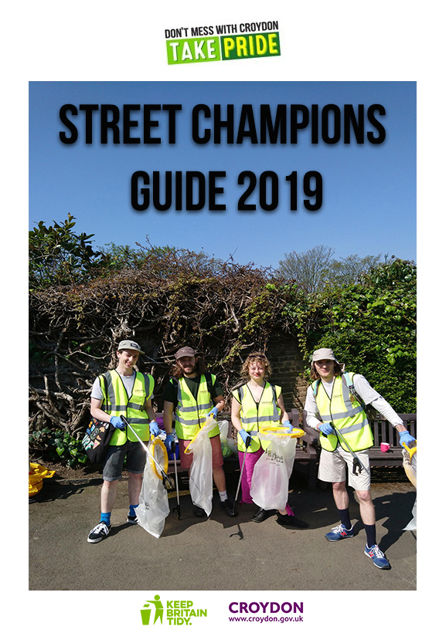

**Contents**

**Introduction - who are the Street Champions? 2 - 3**

**Organising a litter pick / community clean-up 4 - 6**

**Safety advice 7**

**Litter pick / community clean-up application form 8**

**Photography, filming, publicity and data storage consent form 9 - 10**

**Litter pick / community clean-up poster templates 11- 12**

**Introduction - who are the Street Champions?**

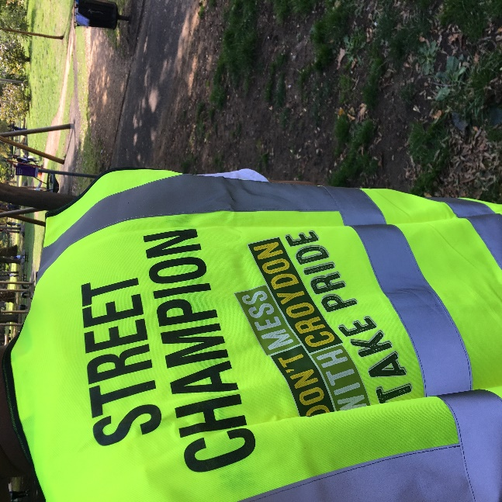The Street Champions are a network of residents who have volunteered to improve the environment in our local area. Champions are local people who work alongside us, Croydon Council, and our partners to encourage their fellow residents and businesses to recycle more, manage their waste responsibly and reduce instances of environmental crime.   
  
We want to take pride in Croydon *and* help the planet. To do this we need more Street Champions to get involved and join us in making a difference.

This guide explains what the Street Champions do, as well as a checklist on how to organise litter picks and community clean-ups along with a mandatory application form to complete ahead of the planned event.

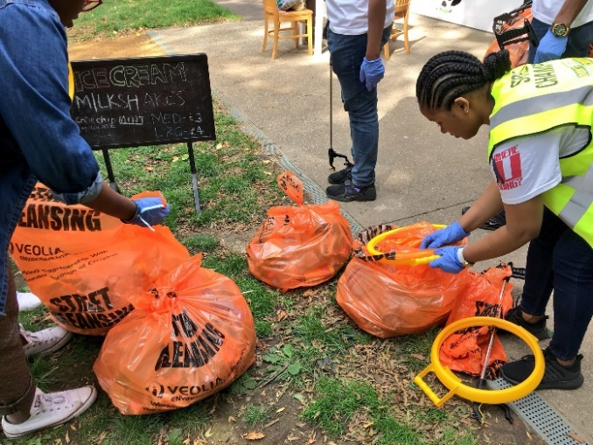If you have any questions about the information in this guide or if you require any assistance, please contact the Street Champions team on [champions@croydon.gov.uk](mailto:champions@croydon.gov.uk) / 0208 726 6200 / 07825 103788.  
 **What does a Street Champion do?**

* Act as our eyes and ears to help make Croydon one of the cleanest, greenest boroughs in London.
* Report environmental crimes such as fly-tipping and littering via the Love Clean Streets phone app or via croydon.gov.uk/myaccount.
* Organise litter picks and community clean-ups.
* Take before, during and after images of litter picks and community clean-up events.
* Support neighbours to keep their front gardens tidy.
* Identify local businesses that need educating on how to dispose of waste and recycling responsibly.
* Attend meetings with fellow residents, street champions and council representatives.
* Report back to the Street Champions coordinator on their activity i.e. litter picks and community clean-ups and engagement with other residents.

**What support do Street Champions receive?**We can help you with the following:

* Help to organise litter-picks and community clean-ups.
* Assistance with land searches.
* Advice on health and safety, risk assessments and preventative methods to reduce environmental crimes.
* Providing equipment and materials for clean-ups, including litter pickers, brooms, gloves and bags.
* Remove all agreed waste collected on community clean-ups.
* Advice on supporting neighbours to keep their front gardens tidy.
* Advice on educating local businesses on how to dispose waste and recycling responsibly.
* Sharing good news about successful litter picks and clean-ups on social media.
* Arrange quarterly meetings with the Street Champions network.

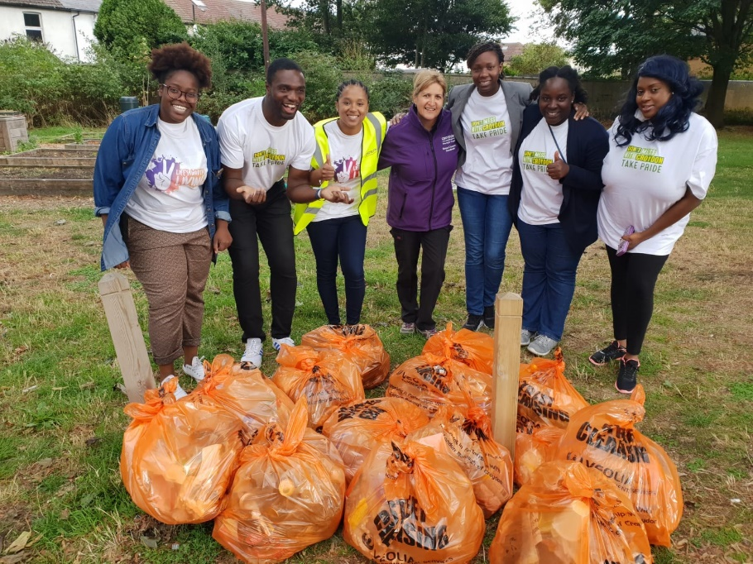

**Organising a litter pick / community clean-up**

 **1. Plan ahead**  Choose an area you want to clean up – perhaps it could be near where you live, or one of Croydon’s many parks and outdoor spaces? If you are not sure how to pick a location you can get in touch with us and we can recommend one for you.

It is important that you let us know about the location so that we can confirm who the land belongs to. If it’s privately owned land, please get permission from the landowner(s). If you need help locating them let us know.

Once you know where you would like to hold your litter pick or community clean-up, decide when you want to do it. If it is a one off event then take into account whom you would like to join in and what their availability might be. Please note that four weeks’ notice is required before a litter pick or community clean-up takes place (see below).

**2. Let us know**Registering means, if you need them, then we can provide you with equipment including:

* Litter pickers
* Litter and recycling bin bags
* Hi-visibility vests and gloves

It also means that we can arrange to have the rubbish taken away by our waste management partners Veolia - you just tell us where and when. You can register by completing a litter pick/community clean-up application form and emailing it to [champions@croydon.gov.uk](mailto:champions@croydon.gov.uk). (See page of 8 of this guide)

**3. Invite others**Make it easy for people to join in - can they just drop by for 10 minutes? Use word of mouth, social media, websites, and community notice boards to advertise your event locally. Feel free to use the poster on page 11 of this guide to spread the message.

If you register your event with us, then we can add it to our webpage calendar and social media accounts and spread the word amongst residents, councillors, visitors and businesses.

If you would like to run regular litter pick and community clean-up events then perhaps we could connect you to other communities around the borough doing the same. This is a great opportunity to share ideas and learn about what works and what can be done better.

**4. Hazards and risks**

  
You can follow the advice on page 6 from [Keep Britain Tidy’s ‘The Great British Spring Clean 2019’](https://www.keepbritaintidy.org/sites/default/files/resources/GBSC19_Host_Guide.pdf).This is a simple way to ensure you have considered any safety issues for the group and taken the necessary precautions to prevent them, as far as is practical. Read on to page 7 of this guide for advice from Croydon’s Community Safety team if you come across dangerous items whilst on a litter pick.

 **5. Checklist**Prepare yourself and your helpers for the day:

* Decide where you will meet and at what time. Select a place that is easily accessible to all.
* Think about if and how to split the group up to cover the area.
* Decide how long you will litter pick and when you will take breaks.
* Think about refreshments and what toilet facilities are available.
* Ensure you have completed litter-pick/community clean-up application form and risk assessment form and emailed to [champions@croydon.gov.uk](mailto:champions@croydon.gov.uk) beforehand.
* Read and print the advice from [Keep Britain Tidy](https://www.keepbritaintidy.org/sites/default/files/resources/GBSC19_Host_Guide.pdf) on litter-pick safety, making sure to brief the group on this.
* Check everyone has appropriate clothing, sunscreen and footwear for the weather and terrain and are issued with a vest.
* Ensure all bags are securely tied and in a safe place for collection. (The collection place should be agreed prior to event day).
* After the event, check in with the Street Champion co-ordinator to confirm that the rubbish has been collected.
* Provide a signing in sheet so you know how many people have volunteered and that you can notify them of any future clean ups.

**6. Feedback**

Tell us how you got on:

* How many people joined in?
* How many bags of rubbish were collected?
* Were there any large objects that needed removing?
* Was there a type of rubbish that you found frequently?
* We’d also love to hear your ideas on how you think we can prevent the problem of litter continuing.
* If you have photos and videos of you and your team in action and are happy for us to use them to promote the Street Champions, please complete the consent form on page 9-10 and send them our way! [champions@croydon.gov.uk](mailto:champions@croydon.gov.uk)

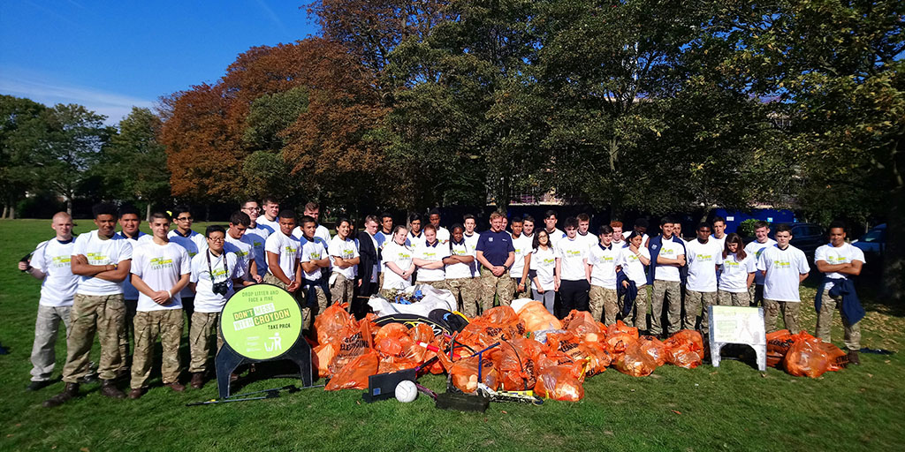

**Safety advice**

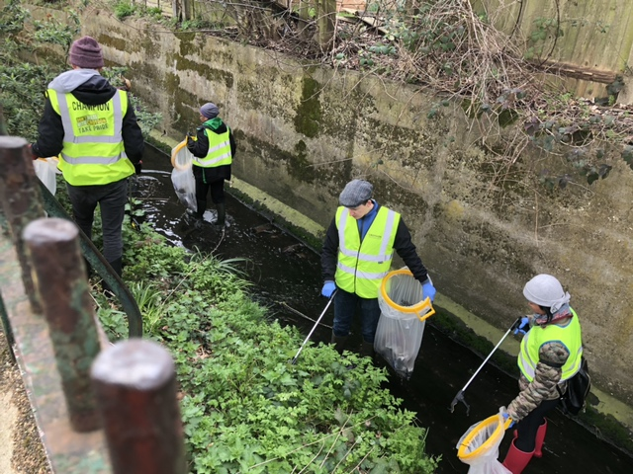If you come across any dangerous items while you are litter picking - anything that has a blade or can be used as weapon such as a knife - please do not move it. Call the nearest Croydon Council Street Champion official to come over, and they will correctly handle and secure the item.

If the item found is a large weapon such as a sword or machete the Street Champion official will call the police on 101 to attend and collect the item.

On the occasion there is no Street Champion official in sight then please call the police on 101 to come and retrieve the item found. If for whatever reason you cannot wait with the suspicious item until the police attend, then please do not leave it. We would ask for you to carefully pick up the knife and keep it in a safe place until police can attend to pick it up. However if the item is visibly blood stained or wrapped in anything, please call 999 immediately. This is for your own safety and to preserve the forensic DNA on the suspected weapon.

In all instances whether there is a Street Champion official present or not, if you feel at all unsafe, at risk or believe that a dangerous item is nearby then do not hesitate to contact 999 straight away.

**Litter pick / Community clean-up application form**

**If you require help completing this form, please contact the Street Champions team on** [**champions@croydon.gov.uk**](mailto:champions@croydon.gov.uk) **/ 0208 726 6200 / 07825 103788.**

|  |  |
| --- | --- |
| **Event date (s)** |  |
| **Event location** |  |
| **Event start and finish time** |  |
| **Name of organisation** |  |
| **Name of event organiser** |  |
| **Contact address (including postcode)** |  |
| **Telephone number** |  |
| **Mobile number** |  |
| **Email address** |  |
| **Website address (if applicable)** |  |
| **Social media handles/accounts (if applicable)** |  |
| **Name of first aider at your event** |  |

**I hereby agree to comply with the Terms and Conditions for holding an event on Croydon Council land and all reasonable instructions given by the Street Champions team.**

|  |  |
| --- | --- |
| **Signed** |  |
| **Print name** |  |
| **On behalf of (organisation)** |  |
| **Date** |  |

**Please complete this application form and email to** [**champions@croydon.gov.uk**](mailto:champions@croydon.gov.uk)



cid:image001.jpg@01CC0FC8.719185E0

C:\Users\097046\AppData\Local\Microsoft\Windows\INetCache\Content.Word\Croydon logo.png

[office use only] Ref:

**Photography, filming, publicity and data storage consent form**

**Please complete this form to give consent for us to take images, moving footage, audio, comments and other personal data to then be stored and used.**

**This form covers consent for use of the above for internal and external communication and storage of the data within this form. All data (images, film, comments, personal info on this form), will be stored by Croydon Council. The data may be shared with 3rd party organisations in order to fulfil the communication work necessary, e.g. providing images to design/ print agencies.**

To find out more about our Privacy Policy visit our website [www.croydon.gov.uk](http://www.croydon.gov.uk), email us at communications@croydon.gov.uk or write to us: **Croydon Council, Bernard Weatherill House, 8 Mint Walk, Croydon, CR0 1EA.**

**Section A) About you:**

Name

Address::

Telephone

Email:

**Section B) About the project or campaign:**

Description

of project / campaign:

Location:

Date:

**Section C) Your signature:**

I give consent to Croydon Council to publish, republish, or otherwise transmit still and moving images, audio and my name for the purposes of:

* Publicity and promotional materials, including advertising material and printed publications
* Presentation and exhibition materials
* Websites, social media channels and digital communications materials, including advertising material and printed publications
* News media and their associated websites, social media channels, print publications, television and radio

I understand the Council will keep all its images in accordance with data protection law and delete the images that have not been used for any publicity or marketing after 2 years. I also understand that the still / moving images / audio used for publicity or marketing purposes are in the public domain and therefore could potentially be reproduced, altered, or re-used by anyone outside

of the Council’s control. I know I have the right to withdraw consent at any time by emailing [**communications@croydon.gov.uk**](mailto:communications@croydon.gov.uk) but understand that withdrawing consent may not affect the material that has already been used.

I am the person identified in Section A and in the photograph(s), filming and/ recording.

I understand the above request and give informed consent.

Signed

Date

**Section D) Signing on behalf of a person aged under 16 years or a vulnerable adult:**

Signature of parent/ guardian or carer:

Print name:

Signature of child (where age appropriate):

Print name:

I am the parent/ guardian/ carer (delete as appropriate) of the person identified in Section A and in the photograph(s), filming and/ recording. I understand the above request and give informed consent for this person’s image/ data to be used **on their behalf.**

Date:

Date:

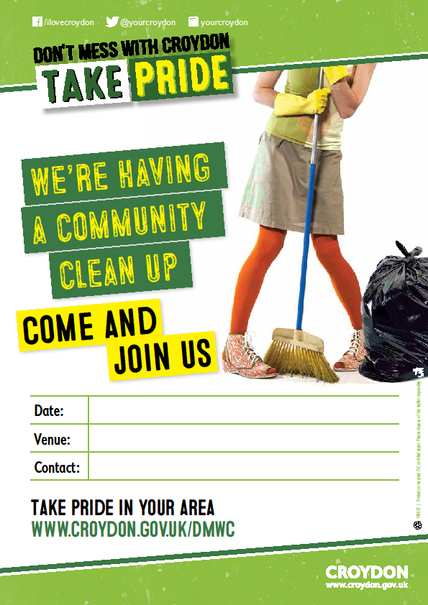

**Champions@croydon.gov.uk**

**Clean up our community meet at Otterbourne Road Car Park**

**28th September 2019 from 10am until 1pm**

