KENDRA Profit & Loss
 | 2023 (£) | 2022 (£)
INCOME
Advertising ^{1, 2, 3} | 4222.80 | 3905.40
Subscriptions ⁴ | 5241.46 | 3260.00
Donations | 205.60 | 290.47
Council Community Grant
Bank Interest | 189.08 | 19.17
Amazon | 3.00
 | 9,861.94 | 7,475.04
EXPENDITURE
Newsletter & Leaflet Printing | 3876.00 | 4328.40
Charity/Donations | 370.00 | 370.00
Minute Taking | 0.88
Memorial Hall Rent | 375.00 | 224.00
Insurance | 193.25 | 332.02
Stationery | 139.82 | 74.81
Postage & Delivery | 22.35 | 285.68
Litter Pick Equipment
Noticeboards | 136.00 | 176.00
Website | 93.96 | 209.47
Miscellaneous, inc. Gifts | 32.00 | 79.99
Parking & Travel
Social Events | 87.95
Subscriptions | 35.00 | 35.00
IT Equipment |  | 271.95
Telephone and Videoconferencing
Equipment rental | 100.00 | 210.00
Professional Fees | 225.00 | 209.00
 | 5,687.21 | 6,806.32
KENDRA (DEFICIT) / SURPLUS FOR THE YEAR | 4,174.73 | 668.72

Dew Pond Sub Account P&L | 2023 (£) | 2022 (£)
INCOME
Council Community Grant | 0.00 | 0.00
Bank Interest | 1.43 | 0.05
EXPENDITURE
General Expenses | 63.60 | 175.94
DEW POND (DEFICIT) / SURPLUS FOR THE YEAR | (62.17) | (175.89)

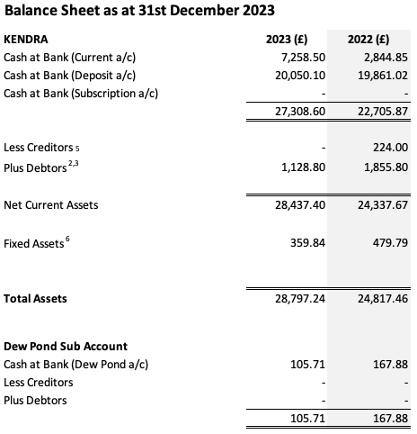

Notes to The Accounts
- Advertising income is recognised in the year it is invoiced.
In respect of calendar years:
 | 2023 (£) | 2022 (£)
2021
2022 |  | 138.00
2023 | 3767.40 | 3,767.40
2024 | 455.40
TOTAL | 4,222.80 | 3,905.40

- 2023 advertising income includes £1,128.80 outstanding at 31/12/23 for advertising invoices. Of this £1,128.80, £1,056.00 was still outstanding at 04/02/24.
- 2023 advertising income excludes £1,855.80 being monies received in 2023 for invoices raised in 2022.
- Subscriptions are recognised when received.
In respect of calendar years:-
 | 2023 (£) | 2022 (£)
2020 |  | 147.00
2021 | 6.00 | 615.00
2022 | 174.00 | 2,100.00
2023 | 3,306.00 | 334.00
2024 | 1,095.46 | 44.00
2025 | 430.00 | 15.00
2026 | 225.00 | 5.00
2027 | 5.00
TOTAL | 5,241.46 | 3,260.00

- The creditors figure is 0 for 2023. Typically the hire of Kenley Memorial Hall would be invoiced in Q1 of the following year. Unusually the 2023 invoice was received and settled in December 2023.
- The fixed assets have an estimated value of £359.84 and are comprised of:-
Asset | Acquired | Cost at purchase | Estimated Value 2023 (£) | Estimated Value 2022 (£)
PA Sound System | 19/10/2009 | £229.00 | £12.81 | £17.09
IT Equipment | 01/08/2018 | £253.98 | £45.20 | £60.27
KENDRA Noticeboards | 05/11/2018 | £549.84 | £97.86 | £130.48
IT Equipment | 26/01/2022 | £271.95 | £203.96 | £271.95
 |  | £1,304.77 | £359.84 | £479.79

I have examined the computerised records and documentation of the Association and find them to be a true and fair representation.
………………………………….. | ……………………………………..
PRINT NAME: | Angela Morrison
Jerry Connor  Kenley Financial | Honorary Treasurer
Independent Examiner

Explanations to the notes.
1. 2023 includes debtor advertising invoices for £1,128.80
This relates to:
Invoice 445 Oven Rescue | £200.00
Invoice 451 Smokin Grill and Bar | £70.00
Invoice 455 Lexus Croydon | £165.00
Invoice 458 Smokin Grill and Bar | £70.00
Invoice 460 Bob Cave | £120.00
Invoice 461 Champ Consultants | £172.80
Invoice 462 Chipstead Services | £48.00
Invoice 464 Lexus Croydon | £165.00
Invoice 465 Riddlesdown Pharmacy | £48.00
Invoice 467 Smokin Grill and Bar | £70.00

2. 2023 excludes 2022 debtor advertising invoices for £1,855.80. £0 remains outstanding as at 31/12/23
This relates to:
Invoice 410 Lexus Croydon | £165.00
Invoice 412 Smokin Grill and Bar | £85.00
Invoice 417 Lexus Croydon | £165.00
Invoice 418 Oven Rescue | £200.00
Invoice 419 Riddlesdown Pharmacy | £48.00
Invoice 421 Smokin Grill and Bar | £85.00
Invoice 423 Andrew Delgrosso | £84.00
Invoice 426 Cornell & Varley | £340.00
Invoice 429 Lexus Croydon | £165.00
Invoice 430 Riddlesdown Pharmacy | £48.00
Invoice 431 Smokin Grill and Bar | £85.00
Invoice 436 Lexus Croydon | £165.00
Invoice 437 Riddlesdown Pharmacy | £48.00
Invoice 433 Champ Consultants | £172.80

3 Creditors Comprise:
N/A

